**Full Stack**

**Assignment**

Assignment

**Software Engineering Assignment**

**MODULE - 1**

**SE – Overview of IT Industry**

Q-1. What is software? What is software engineering?

Ans. Software is a set of instructions that tells your device what to do.

Example. “Google Chrome” google chrome allows users to connect to the internet provide fast or secure way to access and navigate websites and web-based applications.

Ans. Software engineering is a branch of computer science. Software engineer that deals with different programming languages for design, development, testing, and maintenance of software.

Example. HTML, CSS, JAVA, C++, PYTHON, JAVASCRIPT, PHP, ect.

Q-2. Explain types of software

Ans. There are 2 types of software.

1). System Software

2). Application Software

1). System Software is the kind of software that helps your computer or device run and work properly. It acts as a link between the user and device.

Example. Operating System (OS), ios, Windows, Android, etc.

2). Application Software is a type of software that is designed to help you preform specific tasks on your computer or device.

Application software is a program through which we can perform specific tasks from our device such as Google Chrome in which we can get information about anything.

Example. “WhatsApp” WhatsApp is a cross-platform messaging application that allows us to send voice messages, text, video calls, images, videos to others through the internet.

Q-3. What is SDLC? Explain each phase of SDLC

Ans. SDLC (Software Development Life Cycle) is a structured process used by software developers to plan, design, develop, test, and maintain software.

SDLC is a cost-effective and time-efficient process.

There are 7 phases of SDLC.

1). Planning

2). Requirements Analysis

3). Design

4). Development

5). Testing

6). Deployment

7). Maintenance

1). Planning

Planning is the foundation of the project where the team decides what to do and how to do it.

2). Requirements Analysis

This means collecting information from users about all the requirements of the software.

3). Design

In this phase developers decide how the software will look, functions, architecture and design are cerates.

4). Development

This is one of the most important and time-consuming phases.

this phase developers write the code based on the design plans, they use programming languages to build the software functionality.

5). Testing

In this phase after finishing the coding, the developer tests the software to ensure that it does not have any bugs or that it works properly.

6). Deployment

After complete testing, deployment is the phase in the SDLC where the completed software is made available for the client/user to use.

7). Maintenance

After deployed the software, the developer works ensuring that software is working as the user requirements.

This phase ensures the software continues to run smoothly and software updated and solving bugs reported by user.

Q-4. What is DFD? Create a DFD diagram on Flipkart

Ans. Data Flow Diagram (DFD) helps show how data moves through a system.

Understanding for developer how the system works in step by step.

DFD making it easier to understand the system's structure.

DFD levels

1). DFD level 0 called context diagram

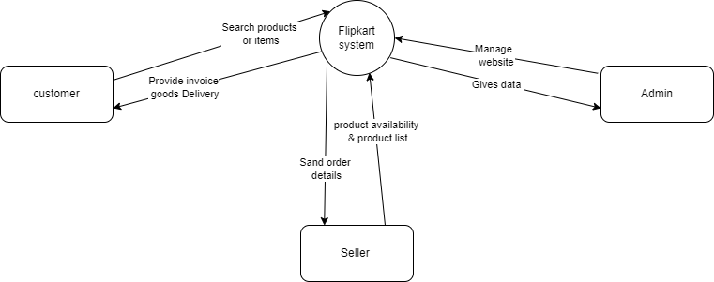

2). DFD level 1

level-1 provides more information than level-0 view of the system.

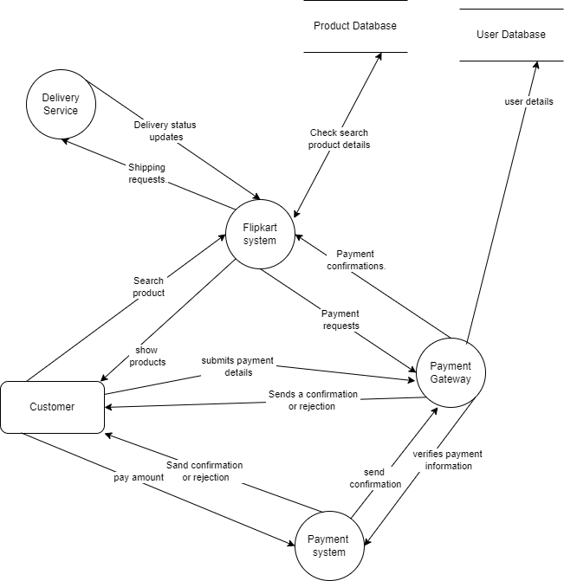

3). DFD level-2

level-2 provides more, more information than level-1 view of the system.

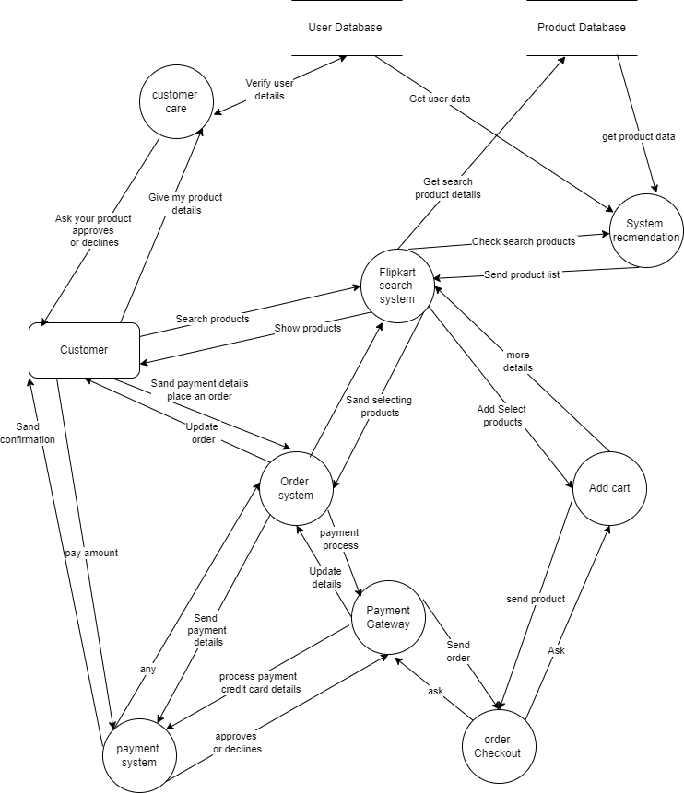 Q-5). What is Flow chart? Create a flowchart to make addition of two numbers 6.

Ans. A flow chart is one that shows how work will flow, Flow Chart Simplifies Complex Processes in Small Steps.

Addition of two number 6

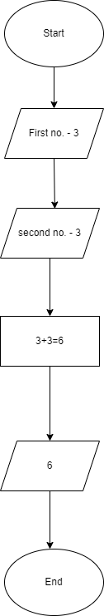

Q-6. What is Use case Diagram? Create a use-case on bill payment on paytm.

Ans. Use case diagram are a simple way of showing how users interact or communicate with a system.

The 4 Main Components of a Use Case Diagram.

1). Actors

2). System

3). Relationship

4). Use cases

Create a use-case on bill payment on paytm.

